**Sketch-Based Rendering from a Few Strokes in Orthographic Views**

CPSC 589 Project Proposal

Yassin Bayoumy (30068194), Emil Hodzic-Santor (30094324), Aly Khedr (30051478)

**Introduction**

We are proposing a sketch-based interface that allows users to quickly and intuitively create 3D models from 2D sketches. We also aim to enable users to export their models by allowing them to 3D print their creations.

Creating 3D models is generally very time-consuming and artistically demanding. As a result, 3D modelling has become less accessible to a large number of people. While most people cannot create highly detailed 3D models, nearly everyone knows how to draw simple sketches; even those that can’t draw well. Creating sketch-based 3D modelling interfaces and improving on existing ones helps make 3D modelling more accessible to the general public.

The proposed sketch-based interface will be implemented using a variety of blending and deformation techniques to allow the creation of 3D models using simple 2D line sketches.

**Problem Statement**

Creating 3D graphics models is a complex, challenging and tedious task, which creates a significant barrier to entry for modelling. This project aims to solve this problem by providing a sketch-based interface to simplify the process of creating 3D models.

**Goals and Objectives**

Our project aims to take a quick 2D sketch from the user and produce an accurate 3D model of the sketch that can be exported to a 3D printer. If the user chooses, they can add an additional sketch of the desired object from a different, orthographic view that will help in creating the desired 3D model.

In the end, this project will allow a beginner user to create custom 3D models that can be exported and printed without going through the hassle of learning advanced modelling tools such as Blender.

**Methodology**

We will achieve our objectives by creating an application using C++ that will render our graphics OpenGL, with a user interface built using the ImGui library. The interface will allow the user to input strokes from orthogonal angles by clicking and dragging with their mouse.

Using methods presented in ‘Sketch-based Modeling with Few Strokes’ [1], we will take these strokes and go through the process of turning them into modifiable curves that can be used to form the mesh of our 3D model. The sketch (or orthogonal sketches) will be blended in a way that satisfies both 2D sketches while creating a realistic 3D model that can be viewed in 3D.

Lastly, the user will have the option to 3D print their object. This will be done by taking the vertices of the mesh of the 3D model and exporting them to a .obj file, which follows a specific format [4].

**Expected results**

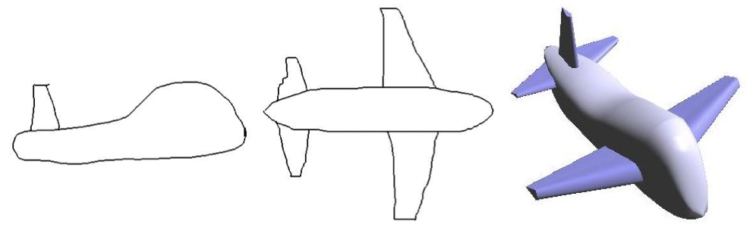

Pictured above: two orthographic sketches (side and top) and a final rendering that combines the two sketches into a 3D model.

**Timeline and Responsibilities**

| **Deadline** | **Person Responsible** | **Milestone** |
| --- | --- | --- |
| Feb 20 | Yassin | Setup basic rendering framework |
| Mar 1 | Aly | Implement a method for taking click and drag input and producing an editable curve |
| Mar 1 | Emil | Recreate method for sketch-based modelling to produce an initial 3D model. |
| Mar 1 | Yassin | Introduce exporting of the model as .obj file (for 3D printing). |
| Mar 15 | Yassin/Aly/Emil | (Optional) Implement orthogonal deformation and cross sectional oversketch |
| Apr 1 | Yassin/Aly/Emil | Create an interface to allow for a second sketch to be added and blend the new sketch with the initial model. |
| Apr 12 | Yassin/Aly/Emil | General improvements (interface, sketching, lighting, etc.) and any extras if we have time (model editing in 3D). |

**Programming Environment (language, library, API, platform)**

Programming Language - C++

Graphics Library - OpenGL

Platform - Windows

**References/Resources:**

[1] Cherlin, Joseph Jacob, et al. “Sketch-Based Modeling with Few Strokes.” *Proceedings of the 21st Spring Conference on Computer Graphics*, 2005, https://doi.org/10.1145/1090122.1090145.

[2] Olsen, Luke, et al. “Sketch-Based Mesh Augmentation.” *Proceedings of the 2nd Eurographics Workshop on Sketch-Based Interfaces and Modeling (SBIM'05)*, 28 Aug. 2005, pp. 43–52., <https://doi.org/10.2312/SBM/SBM05/043-052>.

[3] Olsen, Luke. “A Taxonomy of Modeling Techniques Using Sketch-Based Interfaces.” *Eurographics 2008 - State of the Art Reports (STARs)*, no. 1017-4656, 14 Apr. 2008, pp. 39–57., https://doi.org/10.2312/egst.20081044.

[4] *Alias/Wavefront OBJ File Format*, https://people.computing.clemson.edu/~dhouse/courses/405/docs/brief-obj-file-format.html